PYTHON PROGRAMMING – CASE STUDY ASSIGNMENT
Name: Yamana Vishal Roll Number: 26001262 Section: CSM-6
Course: Python Programming Year: B.Tech First Year
CASE STUDY 1: ATTENDANCE RECOVERY COMPUTATION
- Problem Statement
Develop a Python program to calculate the number of additional classes a student must attend to achieve the required attendance percentage. The program should accept the total classes conducted, classes attended, and target attendance percentage. It should validate the input and use a while loop to calculate the required additional classes.
- Objectives
  - To calculate the current attendance percentage.
  - To determine the additional classes required.
  - To use while loops and conditional statements.
  - To validate user input.
- Assumptions
  - Total classes conducted must be greater than zero.
  - Classes attended cannot exceed total classes conducted.
  - Target attendance must be between 0 and 100.
  - The student attends every additional class.
- Algorithm
- Start.
- Read total classes conducted.
- Read classes attended.
- Read target attendance percentage.
- Validate the entered values.
- Calculate current attendance percentage.
- Initialize additional classes to zero.

- Repeat until the required attendance is reached:
  - Increase additional classes by one.
  - Calculate the new attendance percentage.
- Display the additional classes required.
- Stop.
- Flowchart

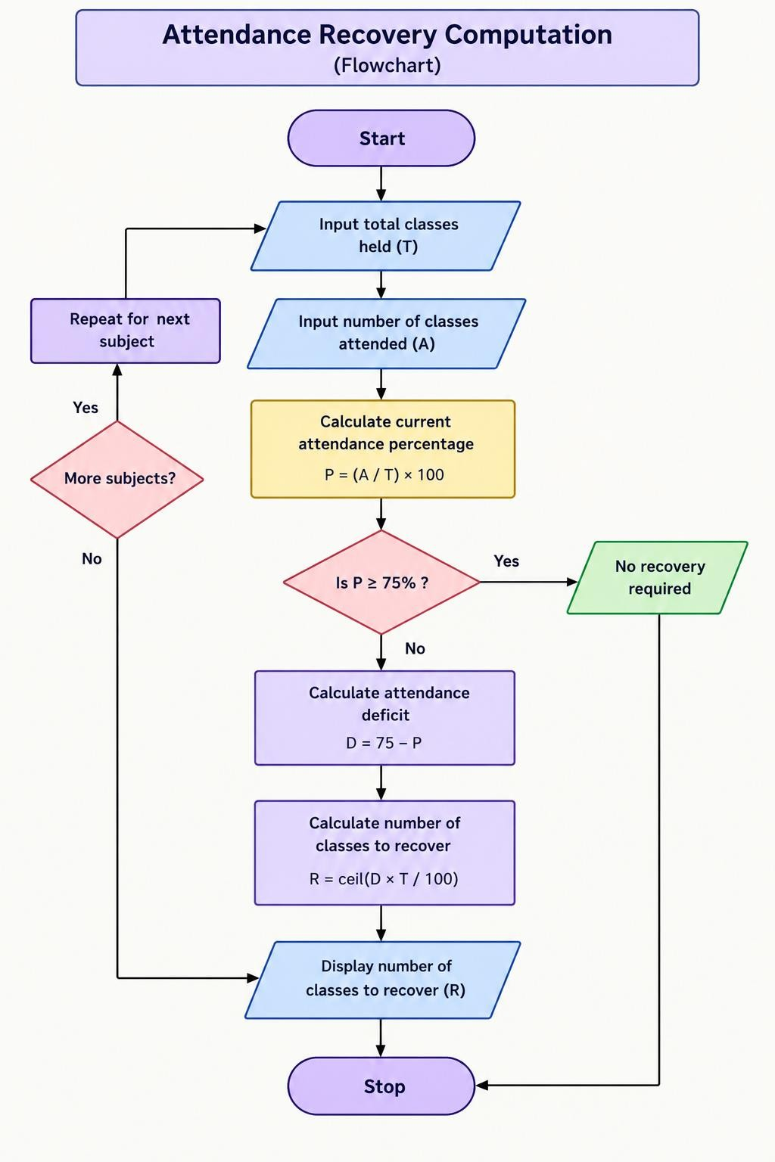

- Python Source Code
conducted = int(input("Enter total classes conducted: ")) attended = int(input("Enter classes attended: "))
target = float(input("Enter target attendance percentage: "))

if conducted <= 0 or attended < 0 or attended > conducted or target < 0 or target > 100:
print("Invalid input")

elif target == 100 and attended < conducted:
print("Target attendance cannot be reached in a finite number of classes")

else:
current = (attended / conducted) * 100 extra = 0

while current < target: extra += 1
current = ((attended + extra) / (conducted + extra)) * 100

print("Current Attendance:", (attended / conducted) * 100) print("Additional classes required:", extra)
print("Final Attendance:", round(current, 2))
- Pseudocode

BEGIN
INPUT conducted, attended, target

IF inputs are invalid THEN

PRINT "Invalid input"
ELSE IF target = 100 AND attended < conducted THEN PRINT "Target cannot be reached"

ELSE
SET extra = 0
CALCULATE current attendance

WHILE current < target extra = extra + 1
CALCULATE new attendance END WHILE

PRINT extra END IF
END
- Test Cases

Test Case | Conducted | Attended | Target | Expected Result
1 | 80 | 48 | 75 | 48 additional classes
2 | 100 | 90 | 75 | 0 additional classes
3 | 50 | 25 | 75 | 50 additional classes
4 | 60 | 30 | 60 | 30 additional classes
5 | 40 | 36 | 90 | 0 additional classes
6 | 20 | 10 | 80 | 60 additional classes
7 | 0 | 0 | 75 | Invalid input
8 | 50 | 55 | 75 | Invalid input
9 | 40 | 20 | 100 | Target cannot be reached
10 | 80 | 60 | 75 | 0 additional classes
- Output Screenshot

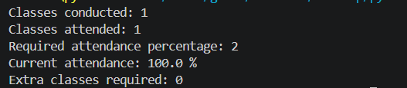
- Conclusion
The program successfully calculates the number of additional classes required to achieve the target attendance percentage using loops and conditional statements. It also validates the input values.
CASE STUDY 2: ADVANCED NUMERIC PATTERN GENERATOR
- Problem Statement
Develop a Python program to generate a diamond-shaped star pattern based on a positive odd integer entered by the user. The program should validate the input and display the pattern using loops.
- Objectives
  - To understand nested loops.
  - To generate patterns using Python.
  - To use conditional statements for input validation.
  - To improve logical and programming skills.
- Assumptions
  - The input must be a positive odd integer.
  - Only star symbols are used.
  - The pattern contains an upper and lower half.
- Algorithm
- Start.
- Read an integer n.
- Check whether n is positive and odd.
- If invalid, display an error message.
- Otherwise, generate the upper half of the diamond.
- Generate the lower half of the diamond.
- Display the complete pattern.
- Stop.

- Flowchart

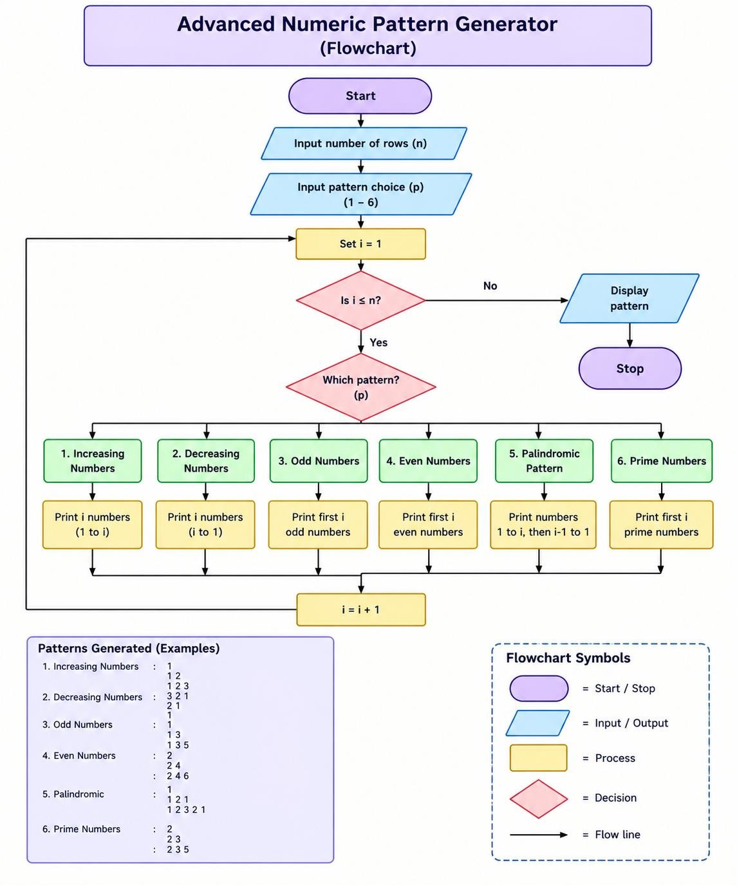

- Python Source Code
n = int(input("Enter a positive odd number: "))

if n <= 0 or n % 2 == 0:
print("Enter a positive odd number") else:
for i in range(1, n + 1, 2): print(" " * ((n - i) // 2) + "*" * i)

for i in range(n - 2, 0, -2): print(" " * ((n - i) // 2) + "*" * i)

- Pseudocode

BEGIN
INPUT n

IF n <= 0 OR n is even THEN PRINT "Invalid input"

ELSE
FOR i = 1 TO n STEP 2
spaces = (n - i) / 2
PRINT spaces and i stars END FOR

FOR i = n - 2 DOWN TO 1 STEP 2
spaces = (n - i) / 2
PRINT spaces and i stars END FOR
END IF END
- Test Cases

Test Case | Input | Expected Result
1 | 5 | Diamond pattern with 5 rows
2 | 3 | Diamond pattern with 3 rows
3 | 7 | Diamond pattern with 7 rows
4 | 1 | One star
5 | 9 | Diamond pattern with 9 rows
6 | 2 | Invalid input
7 | 4 | Invalid input
8 | 0 | Invalid input
9 | -5 | Invalid input
10 | 11 | Diamond pattern with 11 rows
- Output Screenshot
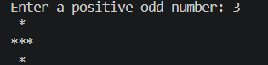
- Conclusion
The program generates a diamond-shaped star pattern using nested loops. It demonstrates the use of loops, conditions, and mathematical calculations in Python.
CASE STUDY 3: PASSWORD POLICY VALIDATION ENGINE
- Problem Statement
Develop a Python program to validate a password based on security requirements. The password must contain a minimum of eight characters, at least one uppercase letter, one lowercase letter, one digit, and one special character.
- Objectives
  - To validate password strength.
  - To use string methods.
  - To understand loops and conditional statements.
  - To improve basic password security.
- Assumptions

  - The password is entered as a string.
  - Minimum password length is eight characters.
  - A special character is any non-alphanumeric character.
  - All five conditions must be satisfied.
- Algorithm
- Start.
- Read the password.
- Check its length.
- Check for uppercase letters.
- Check for lowercase letters.
- Check for digits.
- Check for special characters.
- If all conditions are satisfied, display valid password.
- Otherwise, display invalid password and the missing requirements.
- Stop.
- Flowchart

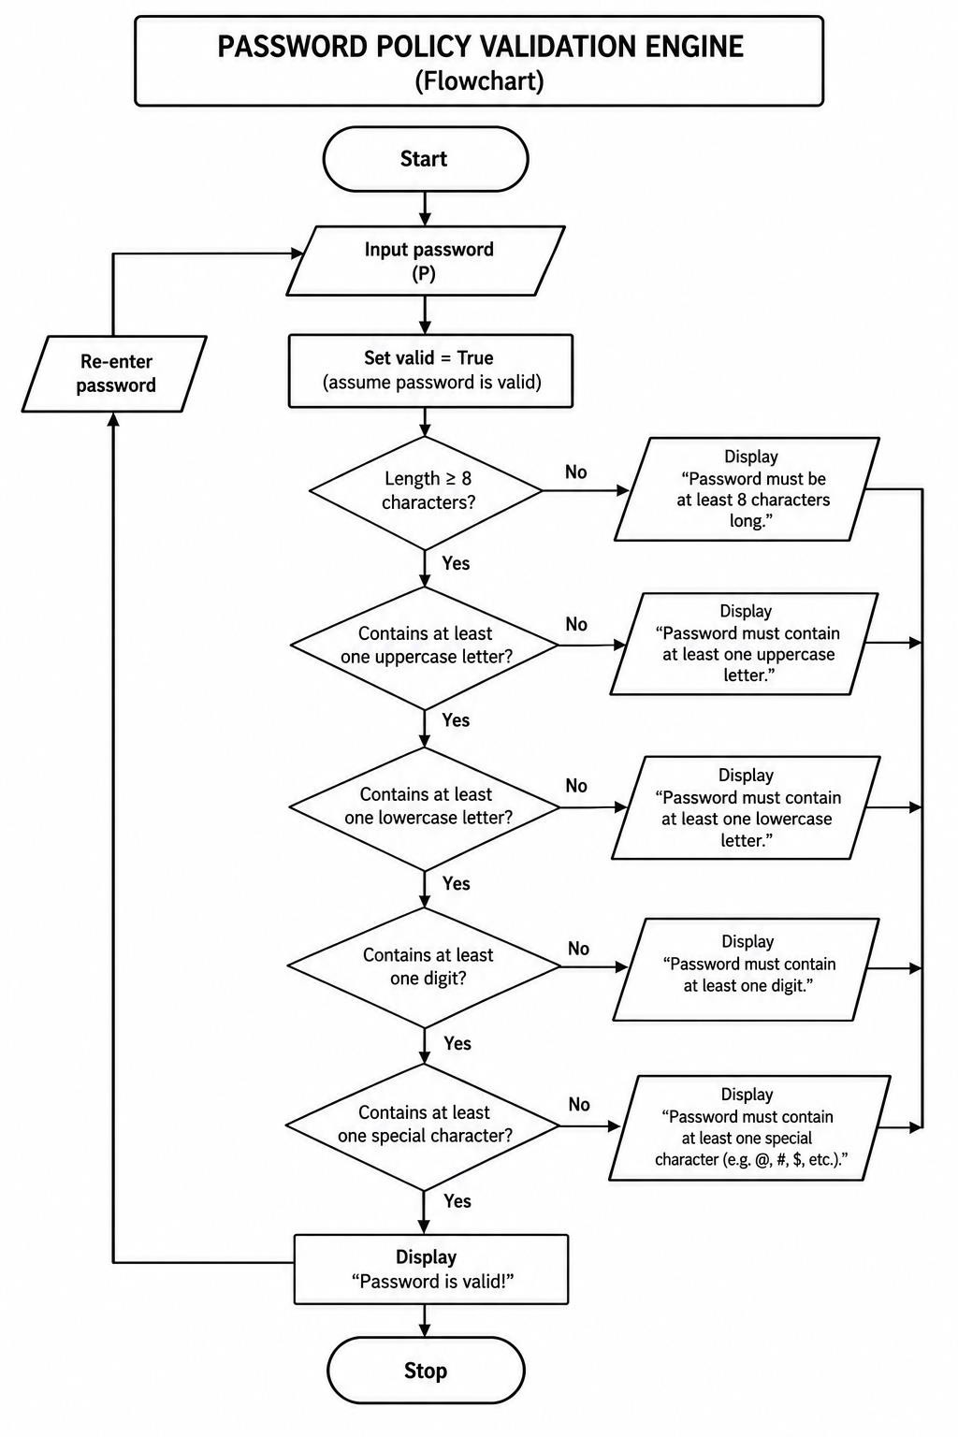

- Python Source Code
password = input("Enter password: ")

if len(password) < 8:
print("Password must have at least 8 characters") elif not any(c.isupper() for c in password):
print("Include an uppercase letter")
elif not any(c.islower() for c in password): print("Include a lowercase letter")
elif not any(c.isdigit() for c in password): print("Include a digit")
elif not any(not c.isalnum() for c in password): print("Include a special character")
else:
print("Password is valid")

- Pseudocode

BEGIN
INPUT password

SET has_upper = False SET has_lower = False SET has_digit = False SET has_special = False

FOR each character in password CHECK whether it is uppercase CHECK whether it is lowercase

CHECK whether it is a digit OTHERWISE mark special character

END FOR

IF length >= 8 AND all checks are True THEN PRINT "Valid Password"

ELSE
PRINT "Invalid Password" END IF
END
- Test Cases

Test Case | Password | Expected Result
1 | Hello@123 | Valid
2 | hello@123 | Invalid – no uppercase
3 | HELLO@123 | Invalid – no lowercase
4 | HelloWorld@ | Invalid – no digit
5 | Hello1234 | Invalid – no special character
6 | Ab@123 | Invalid – length less than 8
7 | Python#2026 | Valid
8 | A1@bcdef | Valid
9 | Password | Invalid – missing requirements
10 | Welcome@45 | Valid
- Output Screenshot
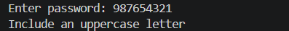
- Conclusion
The program validates passwords based on multiple security conditions. It demonstrates the use of string functions, loops, Boolean variables, and conditional statements.

CASE STUDY 4: STRING-BASED EXAMINATION ANSWER EVALUATION
- Problem Statement
Develop a Python program to evaluate a student's examination answers by comparing them with an answer key. The program should calculate correct answers, wrong answers, unanswered questions, and the final score. Each correct answer carries one mark, each wrong answer has a negative mark of 0.25, and unanswered questions carry zero marks.
- Objectives
  - To compare two strings.
  - To evaluate examination answers.
  - To calculate marks using conditions.
  - To handle unanswered questions.
- Assumptions
  - Answer key and student answers must have equal lengths.
  - Answers are represented using letters.
  - A hyphen (-) represents an unanswered question.
  - Correct answer = +1 mark.
  - Wrong answer = -0.25 mark.
  - Blank answer = 0 marks.
- Algorithm
- Start.
- Read the answer key.
- Read the student's answers.
- Convert both strings to uppercase.
- Remove unnecessary spaces.
- Check whether both strings have equal lengths.
- Initialize correct, wrong, and blank counters to zero.
- Compare each answer:
  - If student answer is blank, increase blank count.
  - If both answers match, increase correct count.

  - Otherwise, increase wrong count.
- Calculate final score.
- Display the result.
- Stop.
- Flowchart

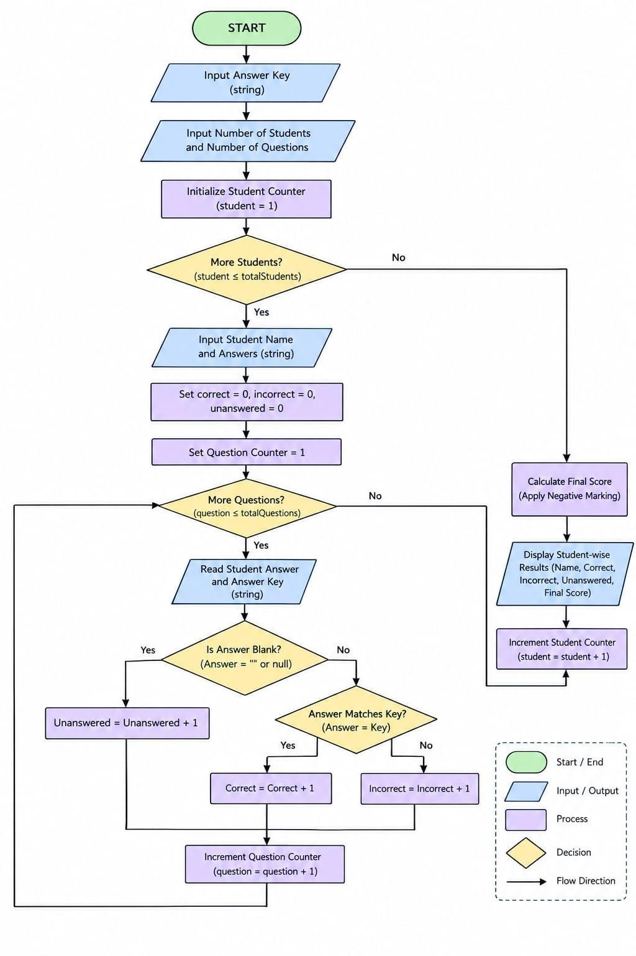

- Python Source Code
key = input("Enter answer key: ").upper()
answers = input("Enter student answers (- for blank): ").upper()

if len(key) != len(answers): print("Answer lengths must be equal")
else:
correct = 0
wrong = 0
blank = 0

for i in range(len(key)): if answers[i] == "-":
blank += 1
elif answers[i] == key[i]: correct += 1
else:
wrong += 1

score = correct - 0.25 * wrong

print("Correct answers:", correct) print("Wrong answers:", wrong) print("Unanswered:", blank) print("Final score:", score)

- Pseudocode

BEGIN
INPUT key, student

CONVERT both strings to uppercase

IF lengths are not equal THEN PRINT error

ELSE
SET correct, wrong, blank = 0

FOR each pair of answers
IF student answer is '-' THEN blank = blank + 1
ELSE IF answers match THEN correct = correct + 1

ELSE
wrong = wrong + 1 END IF

END FOR

score = correct - (wrong * 0.25)

PRINT correct, wrong, blank, score END IF
END
- Test Cases

Test Case | Answer Key | Student Answers | Expected Result
1 | AB-D | ABCD | 3 correct, 0 wrong, 1 blank; score 3.0
2 | ABCD | ABCD | 4 correct; score 4.0
3 | ABCD | DCBA | 0 correct, 4 wrong; score -1.0
4 | ABCD | A- -D | 2 correct, 0 wrong, 2 blank; score 2.0

5 | ABCD | AB-D | 3 correct, 0 wrong, 1 blank; score 3.0
6 | ABCD | ABCE | 3 correct, 1 wrong; score 2.75
7 | ABCD | ---- | 4 blank; score 0
8 | ABCD | ABC | Length mismatch error
9 | abcd | ABCD | 4 correct; score 4.0
10 | ABCD | A-CD | 3 correct, 0 wrong, 1 blank; score 3.0
- Output Screenshot
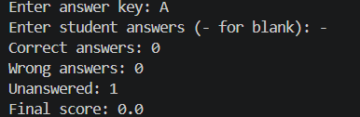
- Conclusion
The program evaluates examination answers by comparing strings and calculating marks. It demonstrates string manipulation, loops, conditional statements, and arithmetic operations.
CASE STUDY 5: TEXT COMPRESSION USING CHARACTER RUNS
- Problem Statement
Develop a Python program to compress text using Run-Length Encoding (RLE). The program should identify consecutive repeated characters and replace them with the character followed by its repetition count.
- Objectives
  - To understand string processing.
  - To implement Run-Length Encoding.
  - To use loops and conditions.
  - To reduce repeated characters in text.
- Assumptions
  - Input is considered as a string.
  - Only consecutive repeated characters are grouped.
  - Character case is preserved.
  - An empty string produces an empty compressed string.

- Algorithm
- Start.
- Read the input text.
- Initialize an empty compressed string.
- Check whether the text is empty.
- If not empty:
  - Set the count to one.
  - Traverse the string character by character.
  - If the next character matches the current character, increase the count.
  - Otherwise, append the current character and its count to the result.
  - Reset the count.
- Append the last character and its count.
- Display the compressed text.
- Stop.
- Flowchart

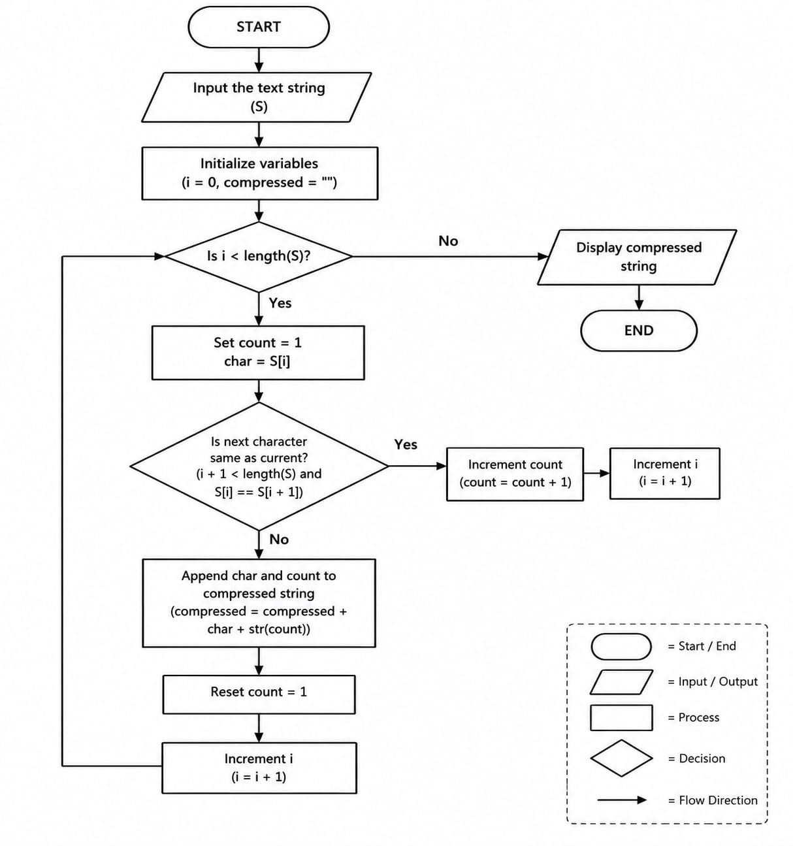
- Python Source Code text = input("Enter text: ")

if text == "":
print("Enter some text") else:
result = "" count = 1

for i in range(1, len(text)): if text[i] == text[i - 1]:
count += 1 else:
result += text[i - 1] + str(count) count = 1

result += text[-1] + str(count)

print("Compressed text:", result) print("Original length:", len(text)) print("Compressed length:", len(result))

- Pseudocode

BEGIN
INPUT text
SET compressed = ""

IF text is not empty THEN SET count = 1

FOR i from 1 to length(text)-1 IF text[i] = text[i-1] THEN
count = count + 1 ELSE
APPEND previous character and count RESET count = 1

END IF END FOR

APPEND last character and count END IF

PRINT compressed END
- Test Cases

Test Case | Input | Expected Output
1 | aaaaabbbb | a5b4
2 | aaabbc | a3b2c1
3 | abc | a1b1c1
4 | aaaaa | a5
5 | aabbcc | a2b2c2
6 | aaAA | a2A2
7 | xxxxxy | x5y1
8 | abbbbbb | a1b6
9 | a | a1
10 | Empty input | Empty output
- Output Screenshot
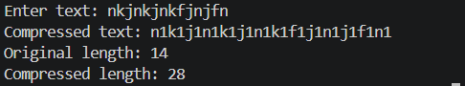
- Conclusion
The program compresses text by counting consecutive repeated characters. It demonstrates string handling, iteration, and basic data compression techniques.
CASE STUDY 6: REPEATED WORD AND PHRASE DETECTION
- Problem Statement

Develop a Python program to identify repeated words in a sentence. The program should convert the sentence into lowercase, remove punctuation, split it into individual words, and identify the words that occur more than once.
- Objectives
  - To perform text analysis.
  - To identify repeated words.
  - To understand string methods and lists.
  - To use loops and conditional statements.
- Assumptions
  - Input is a sentence.
  - Uppercase and lowercase versions of a word are treated as the same.
  - Common punctuation marks are removed.
  - A word is repeated if it occurs more than once.
- Algorithm
- Start.
- Read a sentence.
- Convert the sentence to lowercase.
- Replace punctuation marks with spaces.
- Split the sentence into words.
- Initialize an empty list for repeated words.
- Traverse each word.
- Count its occurrences.
- If its count is greater than one and it is not already recorded, add it to the repeated words list.
- Display the repeated words.
- Stop.
- Flowchart

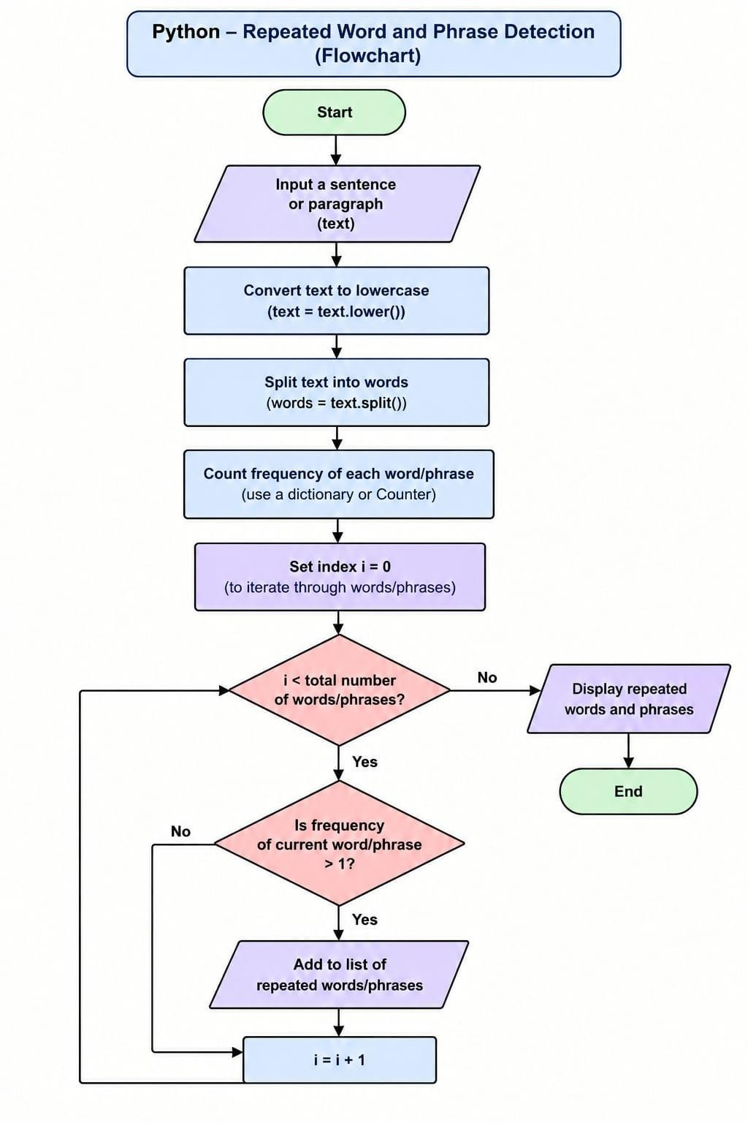

- Python Source Code
sentence = input("Enter a sentence: ").lower()

for mark in ".,!?;:":
sentence = sentence.replace(mark, " ")

words = sentence.split()

found = False

for i in range(len(words)): word = words[i]

if word not in words[:i] and words.count(word) > 1: print(word, "appears", words.count(word), "times") found = True

if not found:
print("No repeated words found")

- Pseudocode

BEGIN
INPUT sentence
CONVERT sentence to lowercase REMOVE punctuation
SPLIT sentence into words

SET repeated = empty list

FOR each word in words
IF count(word) > 1 AND word not in repeated THEN ADD word to repeated

END IF END FOR

IF repeated is not empty THEN PRINT repeated

ELSE
PRINT "No repeated words found" END IF
END
- Test Cases

Test Case | Input | Expected Result
1 | Python is easy and Python is powerful | python, is
2 | This is a test | No repeated words
3 | apple mango apple | apple
4 | Hello hello world | hello
5 | cat dog cat dog | cat, dog
6 | Programming is fun | No repeated words
7 | A a A | a
8 | Data science data analysis | data
9 | Good morning good day | good
10 | One two three four | No repeated words
- Output Screenshot
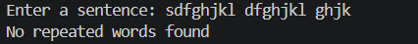

- Conclusion
The program identifies repeated words in a sentence using string processing and list operations. It is useful in basic text analysis and duplicate word detection.
CASE STUDY 7: STUDENT MARKS MATRIX ANALYSIS
- Problem Statement
Develop a Python program to analyze student marks using a two-dimensional matrix. The program should calculate the total marks of each student and identify the student who obtained the highest total marks.
- Objectives
  - To understand two-dimensional lists.
  - To calculate student totals.
  - To compare student performance.
  - To identify the highest-scoring student.
- Assumptions
  - Three students are considered.
  - Each student has marks in three subjects.
  - Marks are stored in a matrix.
  - The highest total represents the best-performing student.
- Algorithm
- Start.
- Initialize student names.
- Initialize the marks matrix.
- Set the highest total to zero.
- Traverse each student's marks.
- Calculate the total marks.
- Display the student's total.
- Compare the total with the highest total.
- Update the highest scorer if necessary.
- Display the highest-scoring student.
- Stop.

- Flowchart
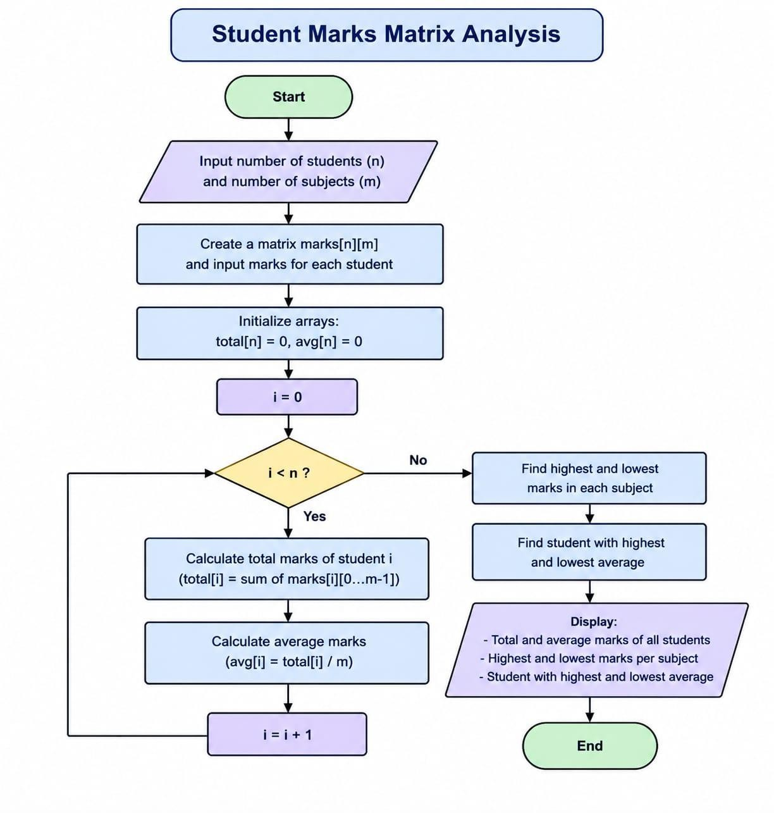
- Python Source Code marks = [
[78, 85, 90],
[88, 76, 92],
[69, 80, 74]
]

names = ["Student 1", "Student 2", "Student 3"]

highest = -1 top_student = ""

for i in range(len(marks)): total = sum(marks[i])
average = total / len(marks[i])

print(names[i], "Total:", total) print("Average:", round(average, 2))

if total > highest: highest = total
top_student = names[i]

print("Top performer:", top_student) print("Highest total:", highest)

- Pseudocode

BEGIN
INITIALIZE students INITIALIZE marks matrix SET highest_total = 0

FOR each student CALCULATE total marks PRINT student and total

IF total > highest_total THEN

highest_total = total top_student = student

END IF END FOR

PRINT top_student PRINT highest_total
END
- Test Cases
The following tests can be performed by changing the marks matrix.

Test Case | Student Marks | Expected Result
1 | Asha: 85,90,80; Ravi: 75,80,70; Kiran:  95,90,100 | Kiran – 285
2 | All students score 50 in each subject | All totals are 150
3 | Asha: 100,100,100 | Asha – 300 if other totals are lower
4 | Ravi: 90,90,90 | Ravi – 270 if other totals are lower
5 | Kiran: 80,80,80 | Kiran – 240 if other totals are lower
6 | All marks are zero | All totals are zero
7 | Asha: 10,20,30 | Asha – 60 if others are lower
8 | Ravi: 95,95,95 | Ravi – 285 if others are lower
9 | Kiran: 100,90,80 | Kiran – 270 if others are lower
10 | Asha: 70,70,70 | Asha – 210 if others are lower
- Output Screenshot

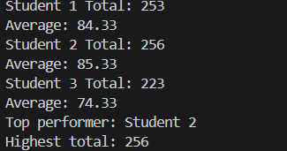
- Conclusion
The program analyzes student marks using a two-dimensional list. It calculates totals and identifies the highest scorer using loops and conditional statements.
CASE STUDY 8: WEEKLY ELECTRICITY CONSUMPTION MATRIX
- Problem Statement
Develop a Python program to analyze weekly electricity consumption using a two-dimensional matrix. The program should calculate the total electricity consumption of each appliance and the total consumption for each day. It should also identify the day with the highest consumption.
- Objectives
  - To understand matrix representation.
  - To calculate row and column totals.
  - To analyze electricity consumption.
  - To identify peak consumption days.
- Assumptions
  - Seven days of electricity consumption are considered.
  - Three appliances are included.
  - Consumption is measured in units.
  - The values are stored in a two-dimensional list.
- Algorithm
- Start.
- Initialize appliance names.
- Initialize day names.
- Initialize the consumption matrix.
- Calculate the total consumption for each appliance.
- Calculate the total consumption for each day.

- Identify the day with maximum consumption.
- Display all totals and the peak day.
- Stop.
- Flowchart

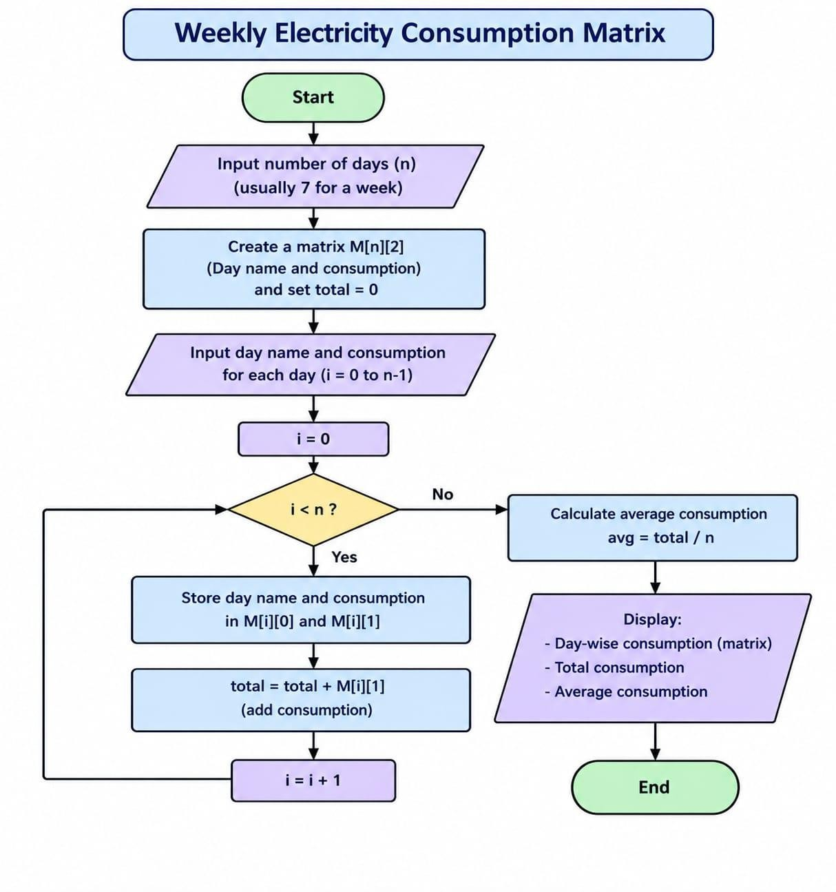
- Python Source Code
days = ["Mon", "Tue", "Wed", "Thu", "Fri", "Sat", "Sun"]

appliances = [
[2, 2, 2, 2, 2, 3, 3],
[1, 1, 1, 1, 1, 2, 2],
[4, 3, 4, 4, 5, 2, 1]
]

names = ["Fan", "Light", "Computer"]

for i in range(len(appliances)):
print(names[i], "weekly usage:", sum(appliances[i]))

daily = []

for j in range(7): total = 0

for i in range(3):
total += appliances[i][j]

daily.append(total) print(days[j], "usage:", total)

peak = daily.index(max(daily))

print("Highest consumption day:", days[peak])

- Pseudocode

BEGIN
INITIALIZE appliances

INITIALIZE days
INITIALIZE consumption matrix

FOR each appliance CALCULATE row total PRINT appliance total

END FOR

FOR each day SET total = 0

FOR each appliance
ADD consumption to total END FOR

STORE daily total PRINT daily total

END FOR

FIND maximum daily total PRINT peak consumption day
END
- Test Cases
The following tests can be performed by changing the consumption matrix.

Test Case | Scenario | Expected Result
1 | Original consumption matrix | Friday – 8 units
2 | All values are zero | All daily totals are zero
3 | Monday has highest values | Monday is peak day

4 | Tuesday has highest values | Tuesday is peak day
5 | Wednesday has highest values | Wednesday is peak day
6 | Thursday has highest values | Thursday is peak day
7 | Saturday has highest values | Saturday is peak day
8 | Sunday has highest values | Sunday is peak day
9 | All days have equal consumption | First day is displayed as peak
10 | Increase computer usage on Friday | Friday total increases
- Output Screenshot
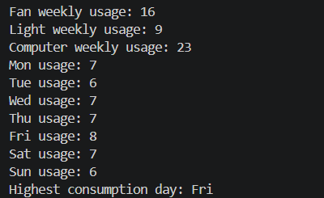
- Conclusion
The program analyzes weekly electricity consumption using a two-dimensional matrix. It calculates appliance-wise and day-wise totals and identifies the day with the highest electricity usage.
CASE STUDY 9: TUPLE-BASED PRODUCT CATALOGUE AUDIT
- Problem Statement
Develop a Python program to maintain and analyze product information using tuples. Each product contains its name, price, and available quantity. The program should calculate the stock value of each product, identify low-stock products, and calculate the total stock value.
- Objectives
  - To understand tuples in Python.
  - To store product information.
  - To calculate stock values.
  - To identify products with low stock.

- Assumptions
  - Product details are stored as tuples.
  - Each tuple contains product name, price, and quantity.
  - Products with quantity below five are considered low-stock products.
  - Stock value is calculated as price multiplied by quantity.
- Algorithm
- Start.
- Initialize the product catalogue using tuples.
- Set total stock value to zero.
- Traverse each product tuple.
- Extract product name, price, and quantity.
- Calculate the product stock value.
- Add the stock value to the total.
- Check whether quantity is below five.
- If yes, display the product as low stock.
- Display the total stock value.
- Stop.
- Flowchart

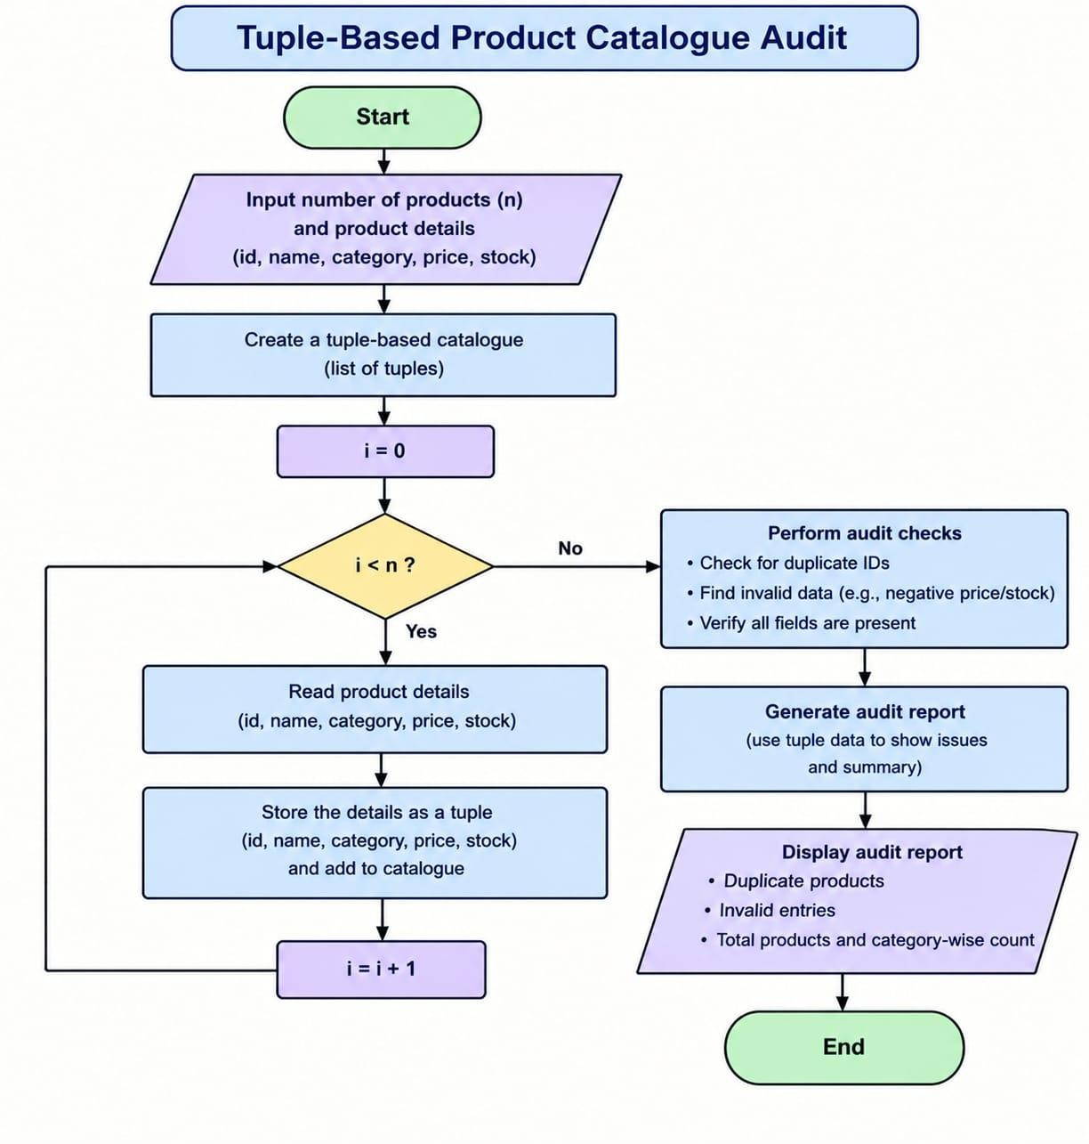
- Python Source Code products = [
("P101", 25.50, 12),
("P102", 10.00, 3),
("P103", 45.00, 0),
("P104", 8.50, 7)
]

total_value = 0

for product_id, price, stock in products: value = price * stock
total_value += value

print("Product:", product_id) print("Inventory value:", value)

if stock < 5:
print("Low stock! Reorder required")

print("Total inventory value:", total_value)

- Pseudocode

BEGIN
INITIALIZE products as tuples SET total_value = 0

FOR each product
EXTRACT name, price, quantity

stock_value = price * quantity total_value = total_value + stock_value

PRINT name and stock_value

IF quantity < 5 THEN PRINT "Low Stock"

END IF END FOR

PRINT total_value END
- Test Cases
The following tests can be performed by changing the product tuples.

Test Case | Product Details | Expected Result
1 | Pen, 25.50, 12 | Value = 306
2 | Notebook, 10, 3 | Value = 30; Low stock
3 | Bag, 45, 0 | Value = 0; Low stock
4 | Pencil, 8.50, 7 | Value = 59.50
5 | Product quantity = 4 | Low-stock alert
6 | Product quantity = 5 | No low-stock alert
7 | Product price = 100, quantity = 2 | Value = 200; Low stock
8 | Product price = 50, quantity = 10 | Value = 500
9 | All quantities are zero | Total stock value = 0
10 | Original catalogue | Total stock value = 395.50
- Output Screenshot
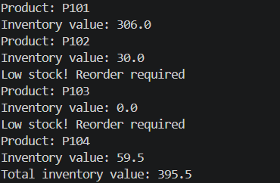
- Conclusion

The program uses tuples to store product information and calculates the stock value of each product. It also identifies low-stock products and determines the total catalogue value.
CASE STUDY 10: FOOD WASTE MONITORING SYSTEM
- Problem Statement
Develop a Python program to monitor food waste over a working week. The program should store the quantity of food prepared and leftover food for each day. It should calculate the percentage of food wasted and display a warning when the waste percentage exceeds the specified limit.
- Objectives
  - To monitor daily food waste.
  - To calculate waste percentages.
  - To use lists and loops.
  - To identify days with excessive food waste.
- Assumptions
  - Five working days are considered.
  - Food quantities are measured in a common unit.
  - Waste percentage is calculated using leftover quantity divided by prepared quantity.
  - The warning threshold is 15%.
  - Prepared food quantity must be greater than zero.
- Algorithm
- Start.
- Initialize day names.
- Initialize prepared food quantities.
- Initialize leftover food quantities.
- Set the waste threshold to 15%.
- Traverse each day.
- Calculate the waste percentage.
- Compare the percentage with the threshold.
- If it exceeds 15%, display a warning.

- Otherwise, display that waste is within the limit.
- Display the results for all days.
- Stop.
- Flowchart

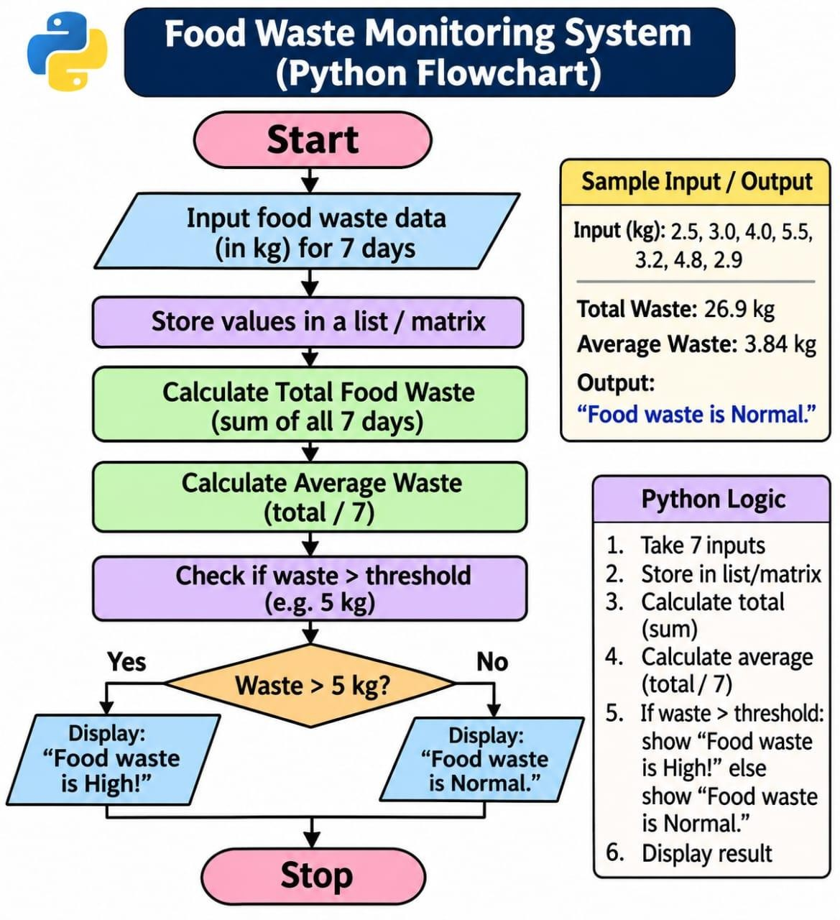

- Python Source Code
days = ["Monday", "Tuesday", "Wednesday", "Thursday", "Friday"]

prepared = [100, 120, 90, 110, 80]
served = [88, 100, 82, 90, 75]

for i in range(len(days)):
leftover = prepared[i] - served[i] waste = leftover / prepared[i] * 100

print("\nDay:", days[i]) print("Leftover meals:", leftover)
print("Waste percentage:", round(waste, 2), "%")

if waste > 15:
print("Warning: High food waste")

- Pseudocode

BEGIN
INITIALIZE days
INITIALIZE prepared quantities INITIALIZE leftover quantities SET threshold = 15

FOR each day
CALCULATE waste percentage

IF waste percentage > threshold THEN PRINT "High food waste"

ELSE
PRINT "Food waste is within limit" END IF

PRINT waste percentage END FOR
END
- Test Cases
The following tests can be performed by changing the prepared and leftover quantities.

Test Case | Prepared | Leftover | Expected Waste
1 | 100 | 10 | 10% – Within limit
2 | 120 | 25 | 20.83% – Warning
3 | 90 | 5 | 5.56% – Within limit
4 | 110 | 20 | 18.18% – Warning
5 | 100 | 18 | 18% – Warning
6 | 100 | 15 | 15% – Within limit
7 | 200 | 50 | 25% – Warning
8 | 80 | 8 | 10% – Within limit
9 | 50 | 20 | 40% – Warning
10 | 0 | 0 | Invalid data; division by zero must be avoided
- Output Screenshot

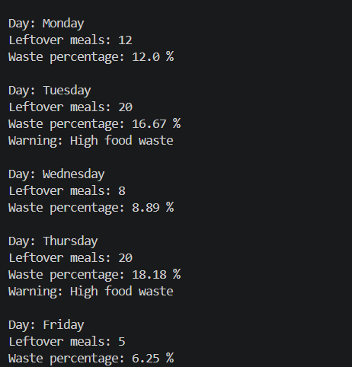
- Conclusion
The program monitors food waste and calculates the daily waste percentage. It identifies days with excessive food waste using a threshold and helps encourage better food management.

